Basics of HTML structure  
(<https://learnweb.link/structure/>)  
Basics of HTML syntax  
Basics of Linking  
Basics of CSS use and syntax  
Basics of CSS specificity and inheritance  
Basics of UX principles as explained in the class up until this point  
<https://codepen.io/robfromerd/pen/mdGvyxe>  
Basics of CSS Transitions and Animations (as explained in the Codepen example linked below)**STUDY GUIDE sources follow**CSS Transitions and Animations:  
<https://codepen.io/robfromerd/pen/zYmrOOJ>HTML Overview:  
<https://developer.mozilla.org/en-US/docs/Learn/HTML/Introduction_to_HTML/Getting_started><https://www.w3schools.com/html/default.asp><https://web.dev/learn/html/overview/>CSS:  
<https://www.taniarascia.com/overview-of-css-concepts/#html-fundamentals><https://web.dev/learn/css/selectors/>Links:<https://robertgoldberg.info/lesson-1.4><https://web.dev/learn/html/links/> (edited)

<!doctype html>

<html>

<head>

<title>

</title>

<style>

</style>

</head>

<body>

<p>

</p>

</body>

</html>

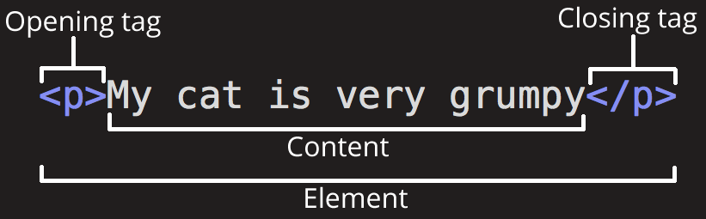

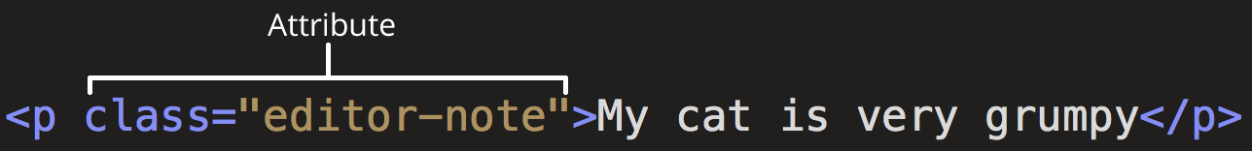

**ATTRIBUTES**

Elements can also have attributes

* Attributes contain extra information about the element that won’t appear in the content. In this example, the class attribute is an identifying name used to target the element with style information.

**NESTING ELEMENTS**

When elements are placed within other elements

* <p>My cat is <strong>very</strong> grumpy.</p>

**VOID ELEMENTS**

Elements that consist of a single tag

* <img src=<https://blah.blahblahblah>.png”>
* <br>
* <link rel=”stylesheet” href=”style.css”>
* etc.

**HREF ATTRIBUTE**

<a> = anchor tag

<href> = hypertext reference attribute (defines the link destination or target)

* <a href=”URL you want to use”>text that will be highlighted when displayed</a>

**DEDCENDANT SELECTOR**

Matches all elements that are descendants of a specified element